Astley St Stephen’s CE School
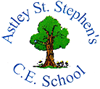

Creative Minds Children’s University
Learning Journey Journal
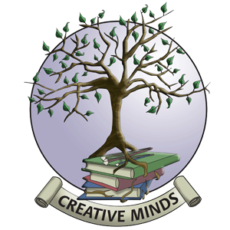

Name _____________________________

Creative Mind’s University Certificates for graduation

All of the certificates can be achieved only once and will be at bronze, silver or gold level.

Creative Minds University Award
At this level children need to participate in and record their learning.
Bronze – 15 Silver – 30 Gold – 45

Creative Minds University Diploma
At this level children must take responsibility for some of their own learning and how it is recorded.
Bronze – 60 Silver – 75 Gold – 90

Creative Minds University Degree
To gain degree level children must have completed activities from across all 4 faculties.
Bronze – 105 Silver – 120 Gold – 135

Creative Minds Postgraduate Diploma
At postgraduate level children must share some of their learning through performing, competing, publishing, exhibiting or recording their learning.
Bronze – 150 Silver – 165 Gold – 180

Creative Minds Master’s Degree
To achieve this level children must have supported the learning of others.
Bronze – 195 Silver – 210 Gold – 225

Honorary Doctorates
These are nominated by staff at school for Y6 pupils who have made an outstanding contribution to learning at school. These are set at Diamond level only

Creative Minds University Faculties Example activities

HUMANITIES  Visiting castles or historic homes  Library days  Publishing writing  Learning a language  Nature Detective website activities  Visiting and recording learning about places  History research projects  Classics at Bolton School  Sunday school  Town trails | SPORTS SCIENCE  Multi sports  Sports clubs  Martial arts  Swimming  House competitions  Sainsbury’s games  ATSA competitions  Outdoor and adventurous activities  Hiking  Cycle journeys  Orienteering  Athletics club  Cross country  
ARTS AND CULTURE  Arts Award  Dance  Theatre visits  Drama clubs  Music lessons  Art Gallery visits  Concerts  Art projects  Art, craft or sewing club  Choir   | SCIENCES  Mathletics  Maths club  Science club  Wildlife visits  Science museums  BQ or Halfords workshops  Technology projects  Cooking club  ICT club  

Please note that for Scouts, Guides, Brownies, Cubs, Beavers, Rainbows, Boys & Girls Brigade and Anchor boys, credits will be given for each badge earned and any camp recorded in the Learning Journey and this will be matched to the appropriate faculty.
Credits will be awarded for each activity (rather than the hours) a child takes part and clearly records in their Learning Journal. Recording can be photographs, project work, signatures of teachers/leaders, scrap booking, learning from a visit etc.

